# pGina Windows 7 OpenLDAP Authentication

We have decided to configure a Windows 7 client to authenticate with LDAP or OpenLDAP. This is a good idea because LDAP is cross-platform and is an extremely stable platform, it also enables ease of administration. Let's get started.

Download/Install pGina, get the stable version

[http://pgina.org/download.html](https://web.archive.org/web/20150423021315/http:/pgina.org/download.html)

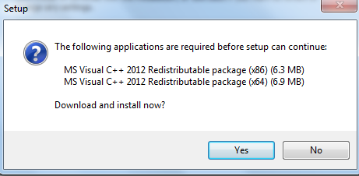

Go ahead and download/install the above proprietary packages

Launch, and configure the plugin section as follows:

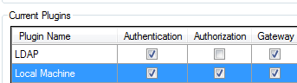

Click on "ldap" and configure

Configure the LDAP servers, separated by a space

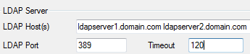

Configure the account to search LDAP, the password, and the group/OU that user accounts are in, and change member attribute to memberUid.

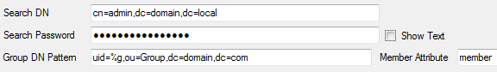

Configure searching for DN as follows:

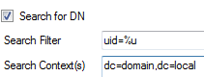

Now browse to the "gateway" tab, and configure a LDAP group to be in the local administrator group

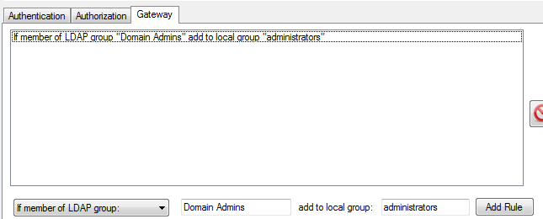

Save Settings, now go to the pGina plugin order, and set LDAP to first like so:

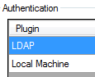

Test your settings with the simulation tab

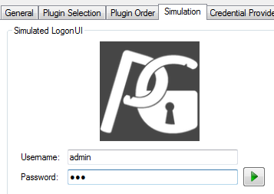

you should see the following:

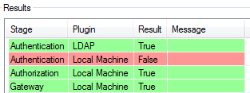

This tells us that LDAP authentication worked, and you do not have a local user account by that name.

Logout, and test your LDAP authentication, it should now work!

# pGina Windows 7 OpenLDAP TLS/SSL Authentication

Login to pGina, and browse to the plugin section

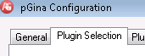

From here select the LDAP module, and then hit "configure"

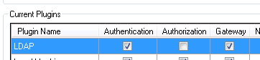

from here you need to change the SSL and port setting as follows:

/var/folders/p8/rrz13_0s62ng9hv2k1590tyh0000gn/T/com.microsoft.Word/Content.MSO/956A39CB.tmp

this uses port 636 and SSL, the default TLS configuration

from here hit apply, you should see a save confirmation

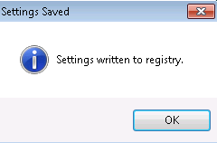

from here we need to test, so browse to the "simulation" tab

Enter your Username/password, and then click the green triangle to re-test the configuration

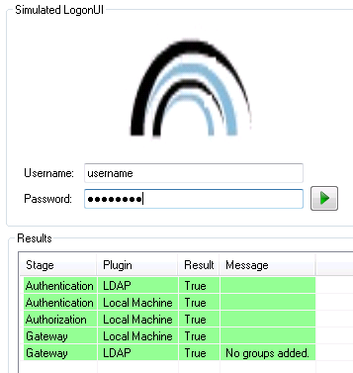

You should see that LDAP authentication worked.

That's it!